Day 1
we introduced ourselves and got familiar with the team.
The mentor explained the project idea on a Receipt and Invoice Digitizer.
The objectives and real-world use cases of the project were discussed. Disscused about the OCR and all

Day 2
teams were formed for collaborative development.
A GitHub repository was created for the project.
All team members were added to a single shared Git repository.

Day3 - Git and Python Basics
Git
Git is a tool used to track changes in code and manage versions of a project.
GitHub
GitHub is an online cloud platform where Git projects are stored and shared using repositories and collaborative team work can be done.
GitLab
GitLab is similar to GitHub and also provides tools for CI/CD and project management.

Basic Git Commands
git add .
Adds all changed files to Git for saving.
git add app.py
Adds only the file app.py to Git.
git clone <https-link>
Downloads a project from GitHub/GitLab to your computer.
git pull
Gets the latest code from the remote repository and updates your local code.
git fetch --all
Downloads updates from the remote repository without changing your code.
git branch --all
Shows all branches (local and remote).
git branch
Shows only local branches.
git checkout <branchname>
Switches to an existing branch.
git checkout -b <newbranchname>
Creates a new branch and switches to it.
git commit -m "message"
Saves your changes with a short message.
git push
Uploads your saved changes to the remote repository.

Python Virtual Environment
python -m venv folder name
Creates a virtual environment with folder name.
Activate virtual environment
Windows:
foldername\Scripts\activate
pip install -r requirements.txt
Installs all required Python packages listed in requirements.txt.
python app.py
Runs the Python program app.py.
deactivate
Stops the virtual environment and returns to the normal system Python.

Day – 4
SDLC – Definitions and Roles
SDLC
SDLC stands for Software Development Life Cycle.
Software Development Life Cycle
It is a step-by-step process followed to design, develop, test, deploy, and maintain software.

SDLC Roles
1. Functional Consultant / Business Analyst
Understands business needs and converts them into clear requirements for the technical team.
Functional Specifications Document (FSD)
A document that explains what the system should do based on business requirements.

2. Developer / Programmer
Developers write and implement the application logic using programming languages.
Technical Specifications Document (TSD)
A document that explains how the system will be built, including technical design and tools.
POC (Proof of Concept)
A small working model created to check if an idea or technology is feasible.
Implement Logic at Code Level
Writing actual program code to achieve the required functionality.
Unit Testing
Testing individual modules or functions to ensure they work correctly.

3. Tester / QA Team
The QA team checks the software to find bugs and ensure quality.
Test Script
A document that lists test cases and steps to test the application.
Test Results
The output of testing that shows passed and failed test cases.

Three Main Servers
Development Server
Used by developers to build and test new features.
Quality (QA) Server
Used by testers to test the application for bugs and issues.
Production Server
The live server where end users use the application.

4. Administration Team
Manages servers, system access, security, and infrastructure.

5. Product / Project Management
Plans, monitors, and controls the project to ensure timely delivery.

6. Sales and Marketing Team
Promotes and sells the product to customers.

7. Human Resource (HR) Team
Manages hiring, employee records, payroll, and workplace policies.

8. Documentation Team
Creates and maintains project documents, manuals, and reports.

9. Support Team
Provides help and fixes issues faced by users after deployment.

SDLC Models
Waterfall Model
A sequential model where each phase is completed before moving to the next.
Agile Methodologies
An iterative approach where development happens in small cycles with continuous feedback.

Agile Roles
1. Product Owner
Defines requirements and prioritizes features.
2. Scrum Master
Facilitates the Agile process and removes obstacles for the team.
3. Development Team
Designs, develops, tests, and delivers the product.

Software Phases
Design
Planning the system structure and architecture.
Development
Writing and implementing the code.
Testing
Checking the software for defects.
Deployment
Releasing the application to users.
Maintenance
Fixing bugs and improving the system after release

DAY-5
API
API (Application Programming Interface) allows frontend and backend to communicate using requests and responses.

Frontend → Backend Flow
Frontend sends request → Backend receives payload → Processes logic → Sends response.

Payload
Payload is the data sent from frontend to backend, usually in JSON format.

HTTP Methods
- GET – Fetch data (no body)
- POST – Send data (payload in body)
- DELETE – Remove data

POST Request
POST request sends payload inside request body.

Flask API
- Flask – creates application
- request – receives payload
- jsonify – sends JSON response
from flask import Flask, request, jsonify
app = Flask(__name__)

FastAPI
Fast, modern API framework with async support.
from fastapi import FastAPI
app = FastAPI()

Flask vs FastAPI
Flask → simple, sync
FastAPI → fast, async, auto docs

Postman
Postman is a tool used to test APIs (GET, POST, DELETE).

HTTPS
Secure HTTP. Data is encrypted using SSL/TLS.

WebSocket
Used for real-time, two-way communication.

Async Functions
Async functions allow non-blocking execution and improve performance.
async def func():
pass

Assignement 1
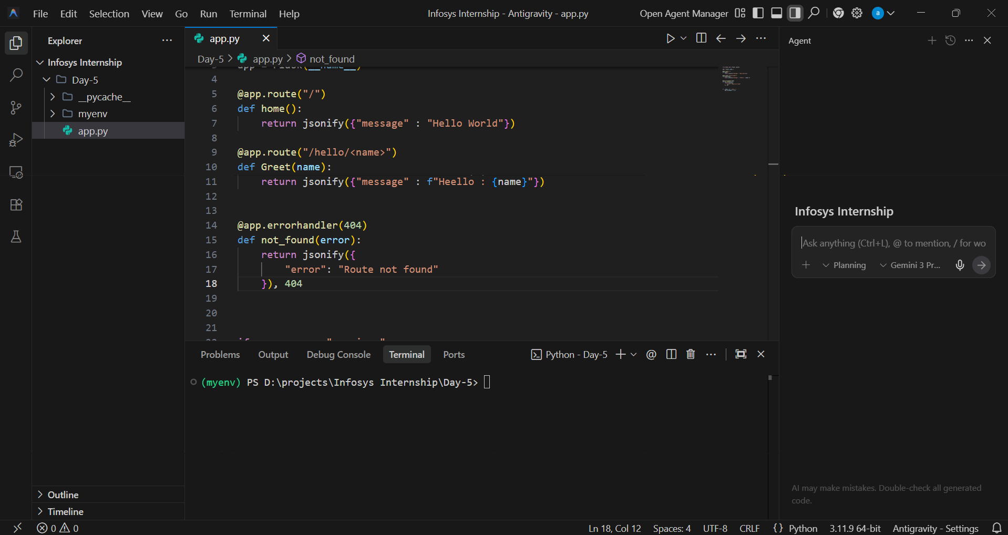

DAY 6
Project work implementation started Basic Frontend and Backend work for Milestone1
Frontend
Login page or registration page
Filed
Name
Email
Password
Preferred language
Backend
JWT
Password hasing
Need to store the password in db

WEEK 2

DAY 7
📘 SQL – Notes
🔹 SQL (Structured Query Language)
- SQL is used to store, retrieve, update, and delete data in a database.
- Used in:
  - 🌐 Websites
  - 📱 Mobile applications
  - 💼 Enterprise software

🔹 Popular SQL Databases
- MySQL
- PostgreSQL
- SQLite

🔹 What can we do using SQL?
- Create a database
- Insert data
- Read data
- Update data
- Delete data

🔹 CRUD Operations in SQL
1️⃣ CREATE (Create database / table)
CREATE DATABASE college;
CREATE TABLE students (
id INT,
name VARCHAR(50),
age INT
);

2️⃣ INSERT (Insert data into table)
INSERT INTO students (id, name, age)
VALUES (1, 'Aisha', 21);

3️⃣ SELECT (Read / Display records)
- Used to display or read records from a table
SELECT * FROM students;
SELECT name, age FROM students;

4️⃣ UPDATE (Update existing data)
UPDATE students
SET age = 22
WHERE id = 1;

5️⃣ DELETE (Delete data)
DELETE FROM students
WHERE id = 1;

🔹 SQL Commands
📌 SELECT Command
- Used to read or display data from a table
SELECT * FROM students;
SELECT name FROM students WHERE age > 20;

🔹 Difference Between DELETE, TRUNCATE, and DROP
🔴 DELETE
- Deletes specific rows
- Uses WHERE
- Table structure stays
DELETE FROM students WHERE age > 20;

🟠 TRUNCATE
- Deletes all rows
- Cannot use WHERE
- Table structure stays
- Faster than DELETE
TRUNCATE TABLE students;

🔵 DROP
- Deletes entire table
- Data + structure removed permanently
DROP TABLE students;

SQL Operators and Clauses – Notes

1. Not Equal Operator (!= or <>)
Definition:
Used to select records where the column value is not equal to a given value.
Example:
SELECT * FROM students WHERE age != 20;
SELECT * FROM students WHERE name <> 'Aisha';

2. AND Operator
Definition:
Used to combine multiple conditions. All conditions must be true.
Example:
SELECT * FROM students
WHERE age > 18 AND age < 25;

3. OR Operator
Definition:
Returns records if any one condition is true.
Example:
SELECT * FROM students
WHERE age = 18 OR age = 21;

4. NOT Operator
Definition:
Used to reverse a condition.
Example:
SELECT * FROM students
WHERE NOT age = 20;

5. ORDER BY
Definition:
Used to sort records in ascending or descending order.
Example:
SELECT * FROM students ORDER BY age;
SELECT * FROM students ORDER BY age DESC;

6. GROUP BY
Definition:
Used to group rows that have the same values in a column, often used with aggregate functions.
Example:
SELECT department, COUNT(*)
FROM students
GROUP BY department;

7. MIN()
Definition:
Returns the smallest value from a column.
Example:
SELECT MIN(age) FROM students;

8. MAX()
Definition:
Returns the largest value from a column.
Example:
SELECT MAX(age) FROM students;

9. AVG()
Definition:
Returns the average value of a numeric column.
Example:
SELECT AVG(marks) FROM students;

10. COUNT()
Definition:
Returns the number of rows.
Example:
SELECT COUNT(*) FROM students;

11. PATTERNS (LIKE Operator)
Definition:
Used to search data using patterns.

a) A%
Definition:
Finds values that start with A.
Example:
SELECT * FROM fruits WHERE name LIKE 'A%';
Result: Apple
b) %a
Definition:
Finds values that end with a.
Example:
SELECT * FROM names WHERE name LIKE '%a';
Result: Sathiya

c) %a%
Definition:
Finds values that contain a anywhere.
Example:
SELECT * FROM items WHERE name LIKE '%a%';
Result: Ball

d) A%e
Definition:
Finds values that start with A and end with e.
Example:
SELECT * FROM fruits WHERE name LIKE 'A%e';
Result: Apple

12. JOIN
Definition:
Used to combine data from two or more tables based on a related column.

13. INNER JOIN (JOIN)
Definition:
Returns only the records that match in both tables.
Example:
SELECT students.name, orders.amount
FROM students
INNER JOIN orders
ON students.id = orders.student_id;

14. LEFT JOIN
Definition:
Returns all records from the left table and matching records from the right table.
Example:
SELECT students.name, orders.amount
FROM students
LEFT JOIN orders
ON students.id = orders.student_id;
1. RIGHT JOIN
Definition:
Returns all records from the right table and matching records from the left table.
If there is no match, NULL is returned for left table columns.
Example:
SELECT students.name, orders.amount
FROM students
RIGHT JOIN orders
ON students.id = orders.student_id;

2. CROSS JOIN
Definition:
Returns the Cartesian product of both tables (every row of first table with every row of second table).
Example:
SELECT students.name, subjects.subject_name
FROM students
CROSS JOIN subjects;

SQL Operators – Notes

3. IN Operator
Definition:
Used to check if a value matches any value in a list.
Example:
SELECT * FROM students
WHERE age IN (18, 20, 22);

4. BETWEEN Operator
Definition:
Used to select values within a given range (inclusive).
Example:
SELECT * FROM students
WHERE age BETWEEN 18 AND 25;

5. LIKE Operator
Definition:
Used to search data using patterns.
Example:
SELECT * FROM students
WHERE name LIKE 'A%';

6. IS NULL
Definition:
Used to check for NULL (empty) values.
Example:
SELECT * FROM students
WHERE email IS NULL;

7. UNION
Definition:
Combines results of two SELECT queries and removes duplicate records.
Example:
SELECT name FROM students_2024
UNION
SELECT name FROM students_2025;

8. UNION ALL
Definition:
Combines results of two SELECT queries and keeps duplicate records.
Example:
SELECT name FROM students_2024
UNION ALL
SELECT name FROM students_2025;

9. INTERSECT
Definition:
Returns common records from both SELECT queries.
Example:
SELECT name FROM class_a
INTERSECT
SELECT name FROM class_b;

10. EXCEPT
Definition:
Returns records that are in the first query but not in the second.
Example:
SELECT name FROM class_a
EXCEPT
SELECT name FROM class_b;

🔑 HAVING Clause
Definition:
Used to filter groups created by GROUP BY.
(It works like WHERE but for groups.)
Example:
SELECT department, COUNT(*)
FROM students
GROUP BY department
HAVING COUNT(*) > 5;

JWT (JSON Web Token)
Definition:
JWT is a compact and secure way to send information between two parties as a signed token.

Parties Involved
- Client
- Server

Purpose of JWT
- Authentication
- Authorization
- Stateless API communication

Why JWT is Stateless
- Server does not store session data
- Token contains user information
- Server only verifies the token

JWT Authentication Flow
- User logs in with username and password
- Server validates credentials
- Server generates a JWT
- Client stores the token
  - localStorage or
  - cookies
- Client sends JWT in request header
- Server verifies the token and allows access

JWT in HTTP Request Header
Authorization: Bearer <JWT_TOKEN>

Installing JWT Library (Python)
pip install pyjwt

Import JWT in Python
import jwt

Key Points to Remember
- JWT is secure and compact
- Used in stateless APIs
- Reduces server storage overhead
- Commonly used in REST APIs

JWT Working Flow
- User Login
  - User sends username and password to the server.
- Credential Validation
  - Server checks whether the credentials are valid.
- JWT Generation
  - If valid, the server creates a JWT.
  - Token is signed using a secret key.
- Token Sent to Client
  - Server sends the JWT back to the client.
- Token Storage
  - Client stores the token in:
    - localStorage OR
    - cookies
- Request with Token
  - Client sends the JWT in every request header:
- Authorization: Bearer <JWT_TOKEN>
- Token Verification
  - Server verifies:
    - Token signature
    - Token expiry
    - Token validity
- Access Granted
  - If token is valid → request is processed
  - If token is invalid/expired → access denied

JWT Flow
Login → Validate → Generate JWT → Store Token → Send Token → Verify → Access

Basic JWT code
import jwt
import datetime

SECRET_KEY = "mysecretkey"

payload = {
"user_id": 101,
"username": "shakthi",
"exp": datetime.datetime.utcnow() + datetime.timedelta(minutes=30)
}

token = jwt.encode(payload, SECRET_KEY, algorithm="HS256")
print(token)

